Setting Up Users in Google Chrome

In the spring of 2019 BCPS activated district managed Google accounts for all teachers, staff, and students. With this change, BCPS users now have access to Google Drive and Google Apps for Education in addition to OneDrive and Microsoft products.

Staff members, and students, can log into their BCPS Google account from the Chrome browser on their Windows device. This will closely mirror the experience that elementary students have on Chromebooks and give staff members access to Google resources.

Remember that when working on a BCPS computer, or the network, there is no assumption of privacy. Linking a personal Google account could make certain information, including browsing history, available to BCPS. BCPS devices and networks are for professional use only.

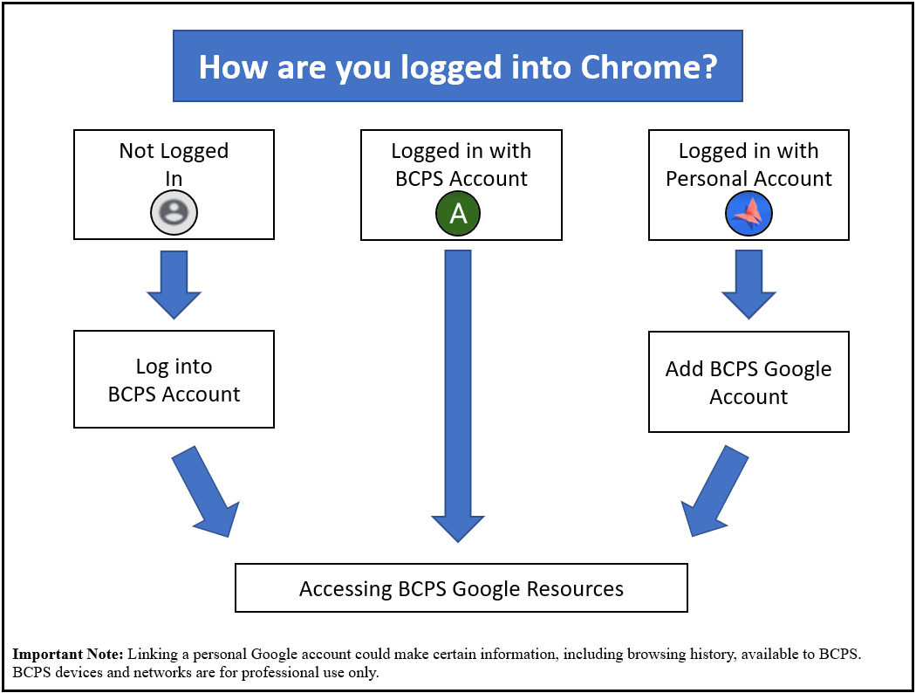

Log into BCPS Account

- Open the Chrome browser and click on the user icon in the upper right-hand corner of the screen (1) and then click Turn on sync (2). NOTE: If the user icon (1) is not the generic grey shown, then the browser is already logged in with a Google account, perhaps a personal one. (see Adding a BCPS Google Account and/or Removing a Google Account in this document.)
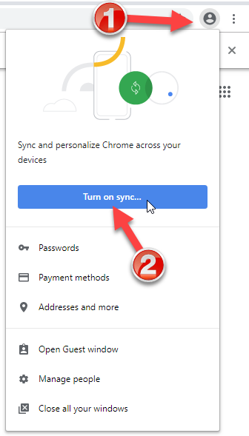
- Log in with your full BCPS email address and BCPS password.
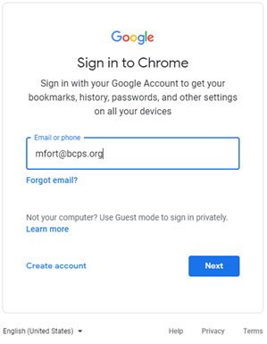
- A message will appear to link your Chrome data. Click Link data acknowledging that BCPS has control of the data in the account.
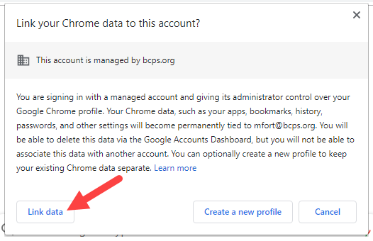
- Click the Settings button. (Clicking the Yes, I’m in button shares ALL information by default.)
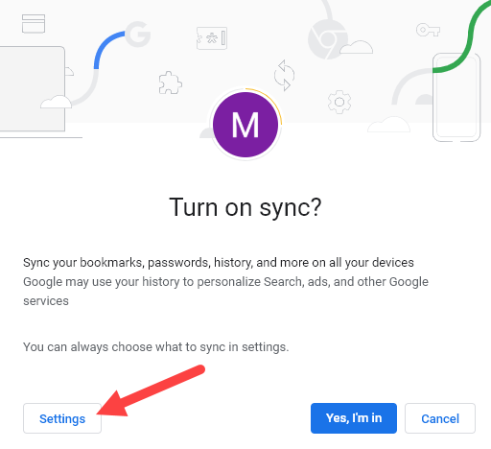
- Click the Manage Sync arrow.
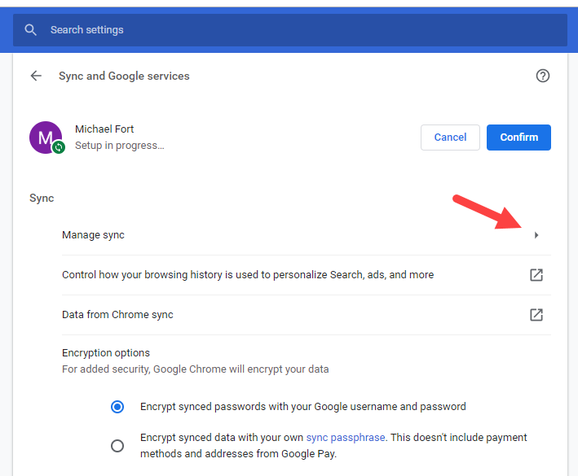
- The Sync everything switch (1) is automatically selected. To choose what is to by synced from device to device, click the switch (1) and then turn on and off the items to be synced from the list below it. After selections are made, click Manage sync (2).
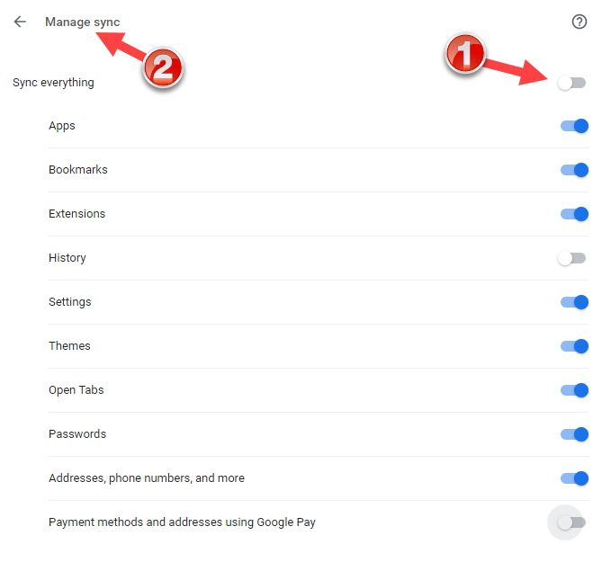
- Click Confirm to complete setup.
- Note: Messages will start to appear that correspond to extensions that are forced installed in the BCPS Google domain. Individual extensions can be turned on an off by right-clicking them (1) and selecting Manage Extensions (2) then turning them off (3). (See graphic on next page.)
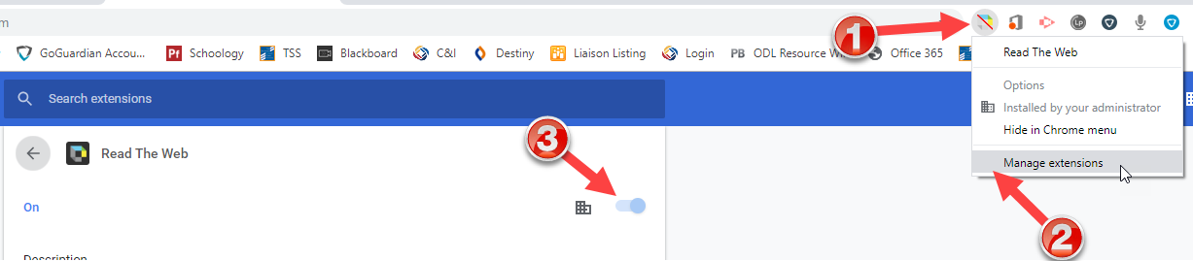
In the upper right-hand corner of the chrome browser an icon will indicate that the BCPS account is logged in.
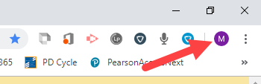

Accessing Google Resources

- Open the Chrome browser and go to www.google.com and be sure to be logged into your BCPS account.
- Click on the Launcher to reveal the available Google resources.
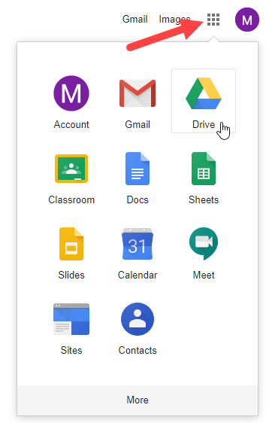

Adding a BCPS Google Account

Important Note: These directions describe how to add the BCPS Google account when a personal account is already connected. Linking a personal Google account could make certain information, including browsing history, available to BCPS. BCPS devices and networks are for professional use only.

- Open the Chrome browser and click the user icon in the upper right-hand corner of the screen (1) and select Manage People (2).
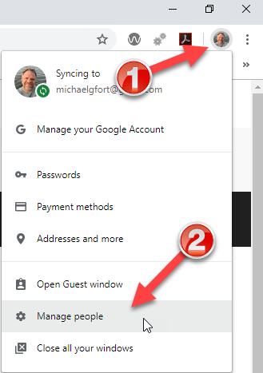
- Click the Add person button.
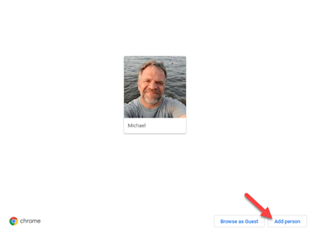
- Type a meaningful name for the account (i.e. BCPS Account) (1) and click the Add button (2). It does not matter what icon is chosen as it will revert to the BCPS Google account icon of the first initial.
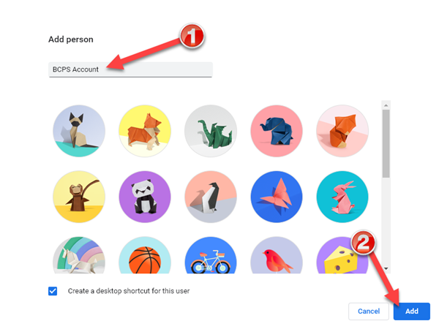
- Click the Already a Chrome user link.
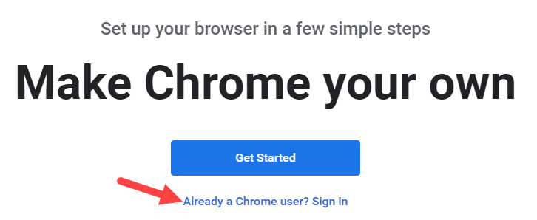
- Sign in with your BCPS credentials (BCPS full email address and password).
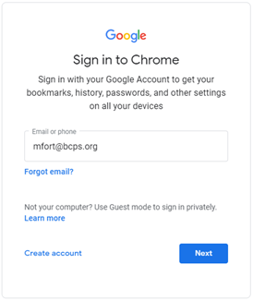
- Click the Link data button that acknowledging that BCPS has control of the data in the account.
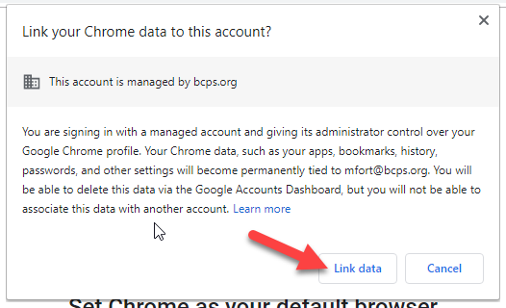
- Click the Settings button. (Clicking the Yes, I’m in button shares ALL information by default.)
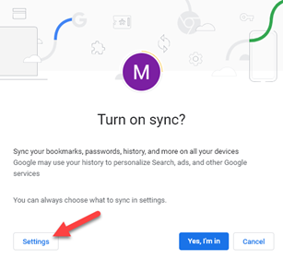
- Click the Manage Sync arrow.
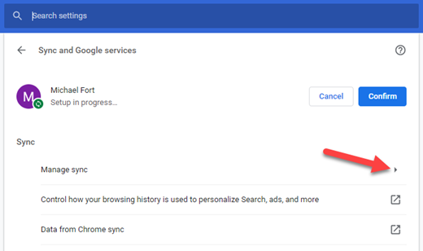
- The Sync everything switch (1) is automatically selected. To choose what is to be synced from device to device, click the switch (1) and then turn on and off the items to be synced from the list below it. After selections are made, click Manage sync (2).
- Click Confirm to complete setup.
- To open your BCPS Google account, click the user icon (1) and select the name for the account (2).
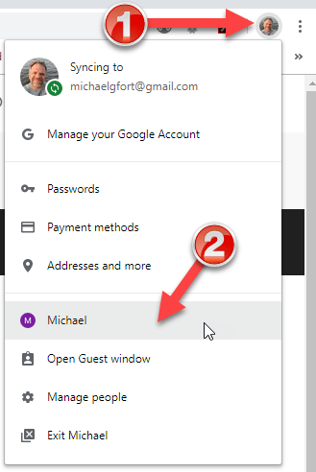
- Notice that a new instance of the Chrome browser opens, one for each account.
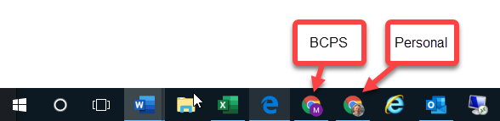

Removing a Google Account

Linking a personal Google account could make certain information, including browsing history, available to BCPS. BCPS devices and networks are for professional use only. These directions document how to remove a personal Google account.

- Open the Chrome browser and click the user icon in the upper right-hand corner of the screen (1) and select Manage People (2).
- Hover over the picture for the personal account that is to be deleted with the mouse. This will reveal three dots in the upper right-hand corner. Click the three dots.
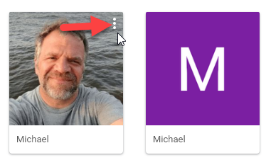
- Select Remove this person.
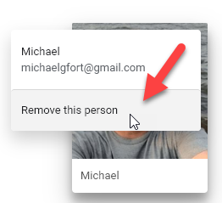
- Click the red button (Remove this person) to complete the process.

